The program that was made used for loops in this assignment to make shapes and designs using ASCII characters. The shapes and designs that were made were a square, a right triangle, a series or vertical stripes, a hollowed out square, and an X shape. The program asks the user two questions, how big to make the shapes and what character to use in the shapes. The program only wants numbers between 5 and 25 so the program will automatically convert any number smaller than 5 into a 5 and any number larger than 25 into 25. No other error handling was used.

Every loop that was used to create the shape was a nested for loop with some having if statements inside the inner loop. The outer for loop generated the rows while the inner for loop generated the columns. Since C++ will not allow you to pin point and generate a character at that point the blank spaces seen in the program are spaces. For example, the X shape would generate a character if the numbers on the inner and outer for loop are equal or if the rows and columns are added up and equal to user input otherwise it would print a space.

One thing that helped was one of the labs had something similar to this but instead of printing characters it printed a times table. From there the loops were changed to print out ASCII characters instead of numbers and the size of the table was changed to be dependent on the user input. Once the square was generated the way it was supposed to be all that was left was to change the conditions on the inner for loop to print the character depending on what coordinate the loop was on.

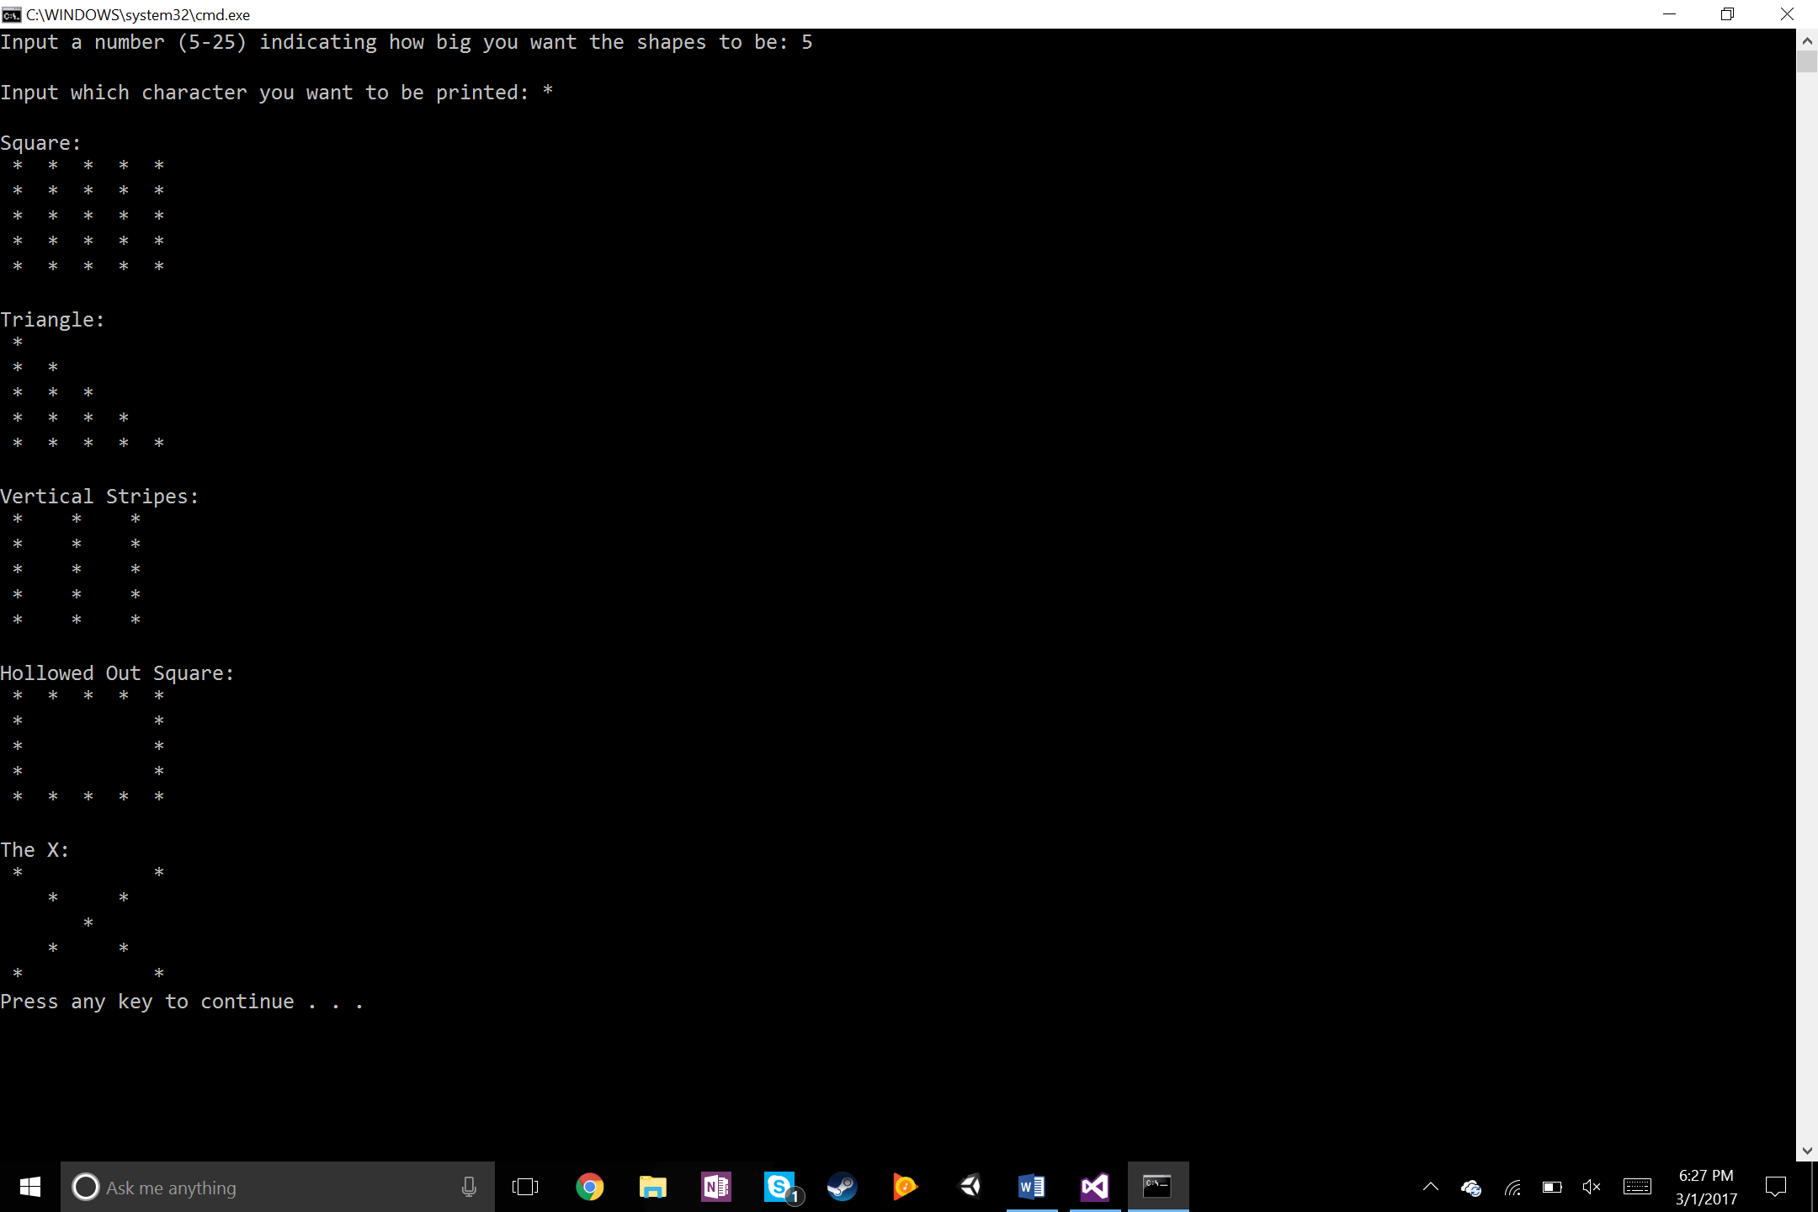

Figure : Preview of console after user input

There weren’t a whole lot of problems with this program other than the loops running from 1-5 instead of 0-4. Normal inputs that were used were 5, or 6 for an even number, and then whatever character the user wanted to be printed out. Everything worked as expected and the only special case scenario that was tested was if the user input was anything other than a integer when asked what size to make the shapes. The program would print out the shapes the way they are supposed to be but the characters are, for lack of a better word, weird. 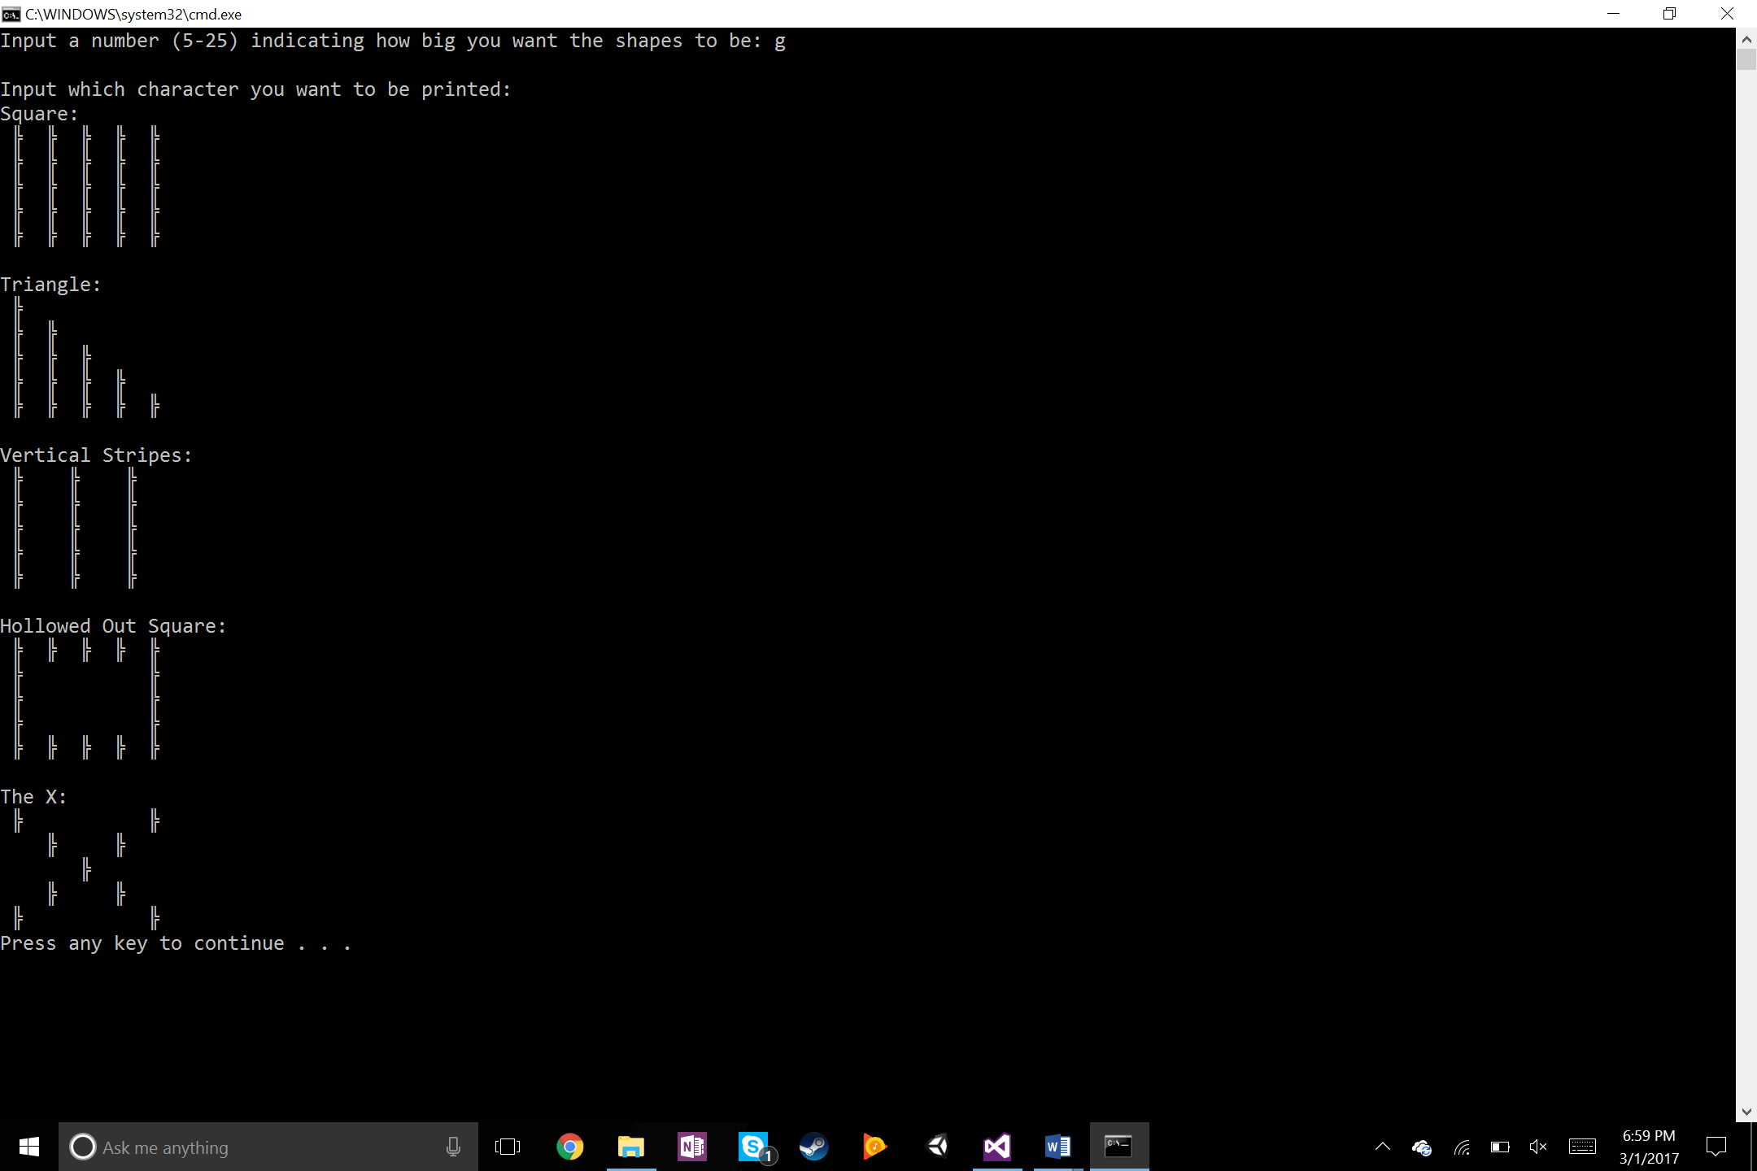

Figure : Special case scenario when the user input was anything other than an integer

The overall result of the program was exactly as expected. The program would convert numbers to 5 and 25 if they were too small or too large, respectively. Once the square was completed and once an understanding of how the nested loops worked was established the rest was pretty simple and was able to be completed within a couple of hours. I would like to find out how to keep the user from entering anything other than a character or an integer when asked.